Jamberoo Public School

Spelling

Scope and Sequence

Table of Contents

Theoretical Links

Spelling Beliefs – aspects and statements

Scope and Sequence of Stage Expectations

Syllabus Outcomes

Suggested Spelling Session Format

Effective Spelling Experiences

Error Detection

Proofreading

Spelling Rules

Grade Core Lists

NAPLAN – Difficult and Challenging Word Lists

Words Their Way Inventories

Glossary

Theoretical Links

“For many students, learning to spell is a complex process that involves them in the act of problem-solving about how to spell accurately the words they want to use. In order for students to improve their spelling competencies they need to acquire the understanding or knowledge that some words can be sounded out (phonological knowledge), some have regular patterns (visual knowledge), some have base meanings that can be built on (morphemic knowledge), and some words originate from a number of languages (etymological knowledge). While engaging in this process they need to draw on the knowledge they have acquired about how words are spelt.”

Focus on Literacy: Spelling pg 8

“Learning to write well involves learning to spell. Writing creates the need for spelling. The purposes for spelling are the purposes of language itself, that is:
- To make meaning, and
- To share meaning in a way that is clearly understood by readers.
Spelling is functional. That is, it is a system for making meaning. Spelling is also social, its purpose being to enable readers to construct meaning. The value of correct spelling is that it gives writers credibility and therefore reaches a wider audience. Understanding the four forms of spelling knowledge and their relationship with the process of learning to spell has significant implications for teaching. Within the context of meaningful written language experiences, students need explicit teaching about the phonological, visual, morphemic and etymological aspects of spelling that are relevant to their stages of development”

Focus on Literacy: Spelling pg 13

Spelling Beliefs
Embedding Spelling in the Classroom

At Jamberoo Public School spelling is explicitly taught through all Key Learning Areas through the teaching of knowledge and strategies that are integrated into the reading and writing process.

The teaching of spelling is about empowering students to use a range of problem solving strategies when attempting to spell unfamiliar words in a range of situations.

This will be achieved by:
- Annual assessment using ‘Words their Way’ Stage appropriate Spelling Inventories to identify individual and whole class needs
- Using diagnostic data from ‘Words their Way’ to develop Teaching / Learning Programs
- Forming appropriate groupings based on assessment data
- Identifying the strengths and weaknesses for individuals and groups
- Establishing targets for individuals and groups
- Using knowledge of student strengths, weakness and targets to systematically plan for the teaching of spelling
- Teaching spelling through modelled and guided spelling lessons as well as within all KLAs
- Explicitly teaching spelling rules
- Instruction will be predominantly through Highly Effective Experiences as well as games and strategies from the Jamberoo PS Spelling Strategies Appendix
- Word lists will be comprised of words from diagnostic evidence gathered through ‘Words their Way’, Theme Words, Grade Core Lists and NAPLAN Difficult and Challenging words and Personal Errors / Demons
- Students will be provided with regular opportunities to locate and correct spelling errors in sentences and paragraphs
- Ongoing assessment through the analysis of student writing samples and rubrics to supplement other formal assessment tools to ensure improved student outcomes
- Monitoring student improvement

7 Key Aspects the Spelling Program

Within classrooms programs teachers should devise learning experiences that focus on:

- Acquiring a large bank of high frequency words – Visual knowledge (see Appendix A)
- Developing understandings of sound–letter patterns – Phonological knowledge
- Understanding how words can change and knowing what rules apply when adding letter combinations – Morphemic knowledge
- Developing knowledge of word origins and derivations of words to generalize patterns within word ‘families’ – Etymological knowledge
- Expanding number of words in their ‘working lexicon’ in terms of word meanings and usage – Vocabulary development
- Gaining control over strategies so they can apply the one most appropriate when spelling and checking unfamiliar words – Authoritative sources
- Error detection and correction; proofreading for errors in common sequential letter patterns; and experience to detect incorrectly used words (homonyms) – Graphological knowledge.

Scope and Sequence of Stage Expectations

Early Stage 1

Sound Awareness

- recognise that words are made up of sounds
- use slow articulation
- join in rhymes and chants
- recognise rhymes and provide a rhyming word, given a predictable context
- segment oral sentences into individual words (using words of one syllable at first)
- segment spoken multi-syllabic words into syllables (eg ba-na-na), using clapping or drum-beats
- say the first sound in a spoken word
- say the last sound in a spoken word (eg in ‘game’ the last sound is ‘m’)
- recognise spoken words that begin with the same sound (eg pat, pin) or a given sound (eg Clap when
you hear a word beginning with ‘m’)
- vocally ‘stretch’ a word (eg m-a-n, b-ea-ch, t-r-ee, sh-o-p), using a hand gesture to support the stretching
concept, to highlight the first, middle and last sounds

Letter–Sound Relationships

- achieve the insight that written words refer to spoken words
- say the most common sounds for all the lower-case letters (to avoid confusion, letters that look alike and
sound alike should not be introduced together, eg ‘b’ and ‘d’, ‘a’ and ‘u’)
- identify new words using known letter–sound relationships, eg using initial letter to guess the word
- blend known letter–sound relationships to form vc (eg at) and cvc (eg sit) spoken and written words.

Spelling
- write their own name using correct spelling
- copy the sequence of letters from models of high-frequency, topic and personal words
- write high-frequency words independently (eg is, I, am, the)
- say and sound while writing the letter for the first sound in a word
- say and write letters for some of the sounds in a word beyond the initial sound, identifying the sounds
through stretching the word (initially with teacher support) — students may still use letter names for
sounds
- spell unknown words phonetically (as they sound), with most of the letters in the correct sequence
- re-read their writing
- underline words that they are unsure of
- use analogy, my/by; tree+duck =truck
- check words from environmental sources, eg calendar, word wall, colour chart, name cards, labels.

Stage 1

Sound Awareness
- in mid Stage 1, segment spoken cv (b-e), vc (o-n) and cvc (l-o-t, p-a-ck, sh-o-p) words into separate sounds
- in early phases of Stage 1, blend single sounds to form a spoken word (cv, vc and cvc words)
- in mid Stage 1, delete onset from a spoken word to utter the rime separately, or to make a new spoken word (eg Say ‘sheet’ without the ‘sh’)
- in mid Stage 1, segment consonant blends (cc, eg s-p-ot, and ccc, eg s-p-l-it) to show awareness of identity of separate phonemes (tr-, dr-, -mp, -nt, -nd, and -nk may need extra explanation, with show to how they are formed in the mouth)
- in later phases of Stage 1, blend single sounds to form a spoken word (ccvc, eg slip, clock, sneeze; cvcc, eg desk, lunch; cccvc, eg street; ccvcc, eg crust)
- manipulate phonemes to make new words, eg exchange one sound in a spoken word with a different sound to make a new word

Letter–Sound Relationships
- understand the difference between letter names and letter sounds
- understand that letter names remain constant but the sounds they represent may vary
- know the names and most common sounds for all single letters
- blend sounds in written vc, cv, cvc words to work out unknown words
- recognise consonant digraphs (eg sh, ch, th, wh, ph)
- recognise common vowel digraphs (eg ea, ay, ar, er, or)
- recognise long vowel sounds (silent ‘e’)
- segment written words into onset and rime (eg slip: sl and ip)
- build word families using words with known rimes (eg using knowledge of ‘day’ to spell ‘bay’ and ‘ray’)
- recognise that common suffixes in words can have different sounds (eg talked, wanted, rubbed)
- identify the sounds of known letter clusters, syllables or rimes in unknown words.

Spelling
- focus on letter sequences and their sounds when copying and learning high-frequency, topic and personal words
- write cv, vc and cvc words that contain known letter–sound relationships
- choose phonetically appropriate letters to represent most of the sounds in unknown words (students may have difficulty with consonant blends)
- use rime analogy to spell new words (eg mop, hop; round, ground)
- use knowledge of familiar letter patterns to spell words, eg -ed, -ing
- spell words using consonant blends, digraphs and long vowel sounds that have been introduced as a component of the reading program
- re-read their writing
- start to use self-correction strategies such as visual and auditory strategies (eg sounding out, sight words) to spell unknown words in own writing
- underline words that are misspelt and correct them
- enter different versions of the word on a ‘Have a go’ pad
- use mnemonics
- slow articulation and chunking
- meaning – two, to, too
- use simple proofreading marks by the teacher
- check authoritative sources around the room including personal dictionary.
Stage 2

Sound Awareness
(In Stage 2, phonemic awareness typically occurs through learning experiences in phonics and spelling activities. Phonemic awareness skills could be consolidated through games and activities where necessary.)
NOTE: This is from the English K-6 syllabus. However, the Literacy Continuum has been developed since this and teachers must refer to the development of these critical aspects on the continuum.
- produce a rhyming word that begins with the same sound (eg Say a word that rhymes with ‘sheet’ but starts with ‘m’)
- delete consonants from consonant blends to make a new word (eg Say ‘smack’ without the ‘m’)
- exchange one consonant within a consonant blend with another consonant to make a new word (eg Say ‘smack’, but instead of ‘m’ say ‘n’)
- delete ‘n’ from final blends (eg Say ‘went’ without the ‘n’)

Letter–Sound Relationships
- add prefixes and suffixes to known words (eg un-, non-, -tion, -ness, -able) eg unhappy, kindness
- read and write contractions (eg shouldn’t)
- match the most common sound to all vowel digraphs (eg cloud) and trigraphs (eg high)
- be familiar with more unusual letter patterns as chunks (eg ‘ough’, ‘scious’)
- be aware of more advanced letter–sound correspondence rules (eg soft c and g before e (eg cent, gent), i (eg city, giant) or y (eg cygnet, gym)

Spelling
- use an increasing bank of known spelling words written automatically
- use known letter patterns and sound sequences, not just individual letters, when spelling unknown words
- classify words into groups according to the way in which they are spelt (eg thought, bought, ought)
- become familiar with the various ways of representing a particular sound in writing (eg meat, meet, metre)
- hypothesise about and learn spelling generalisations (eg i before e except after c; y to i rule for plurals; doubling consonants)
- use known word parts when spelling unknown words (eg prefixes, suffixes, compound words)
- consider meaning and context when spelling words (eg when differentiating between homonyms such as their/there/they’re)
- correctly represent consonant blends when spelling unknown words
- use common consonant and vowel digraphs in attempting unknown words
- use mnemonics for spelling irregular or difficult words (eg ‘piece of pie’)
- increasingly use visual and phonetic self-correction strategies in editing own work (words that do not look or sound right)
- use various spelling resources, eg spell check, dictionary, wall dictionaries, word charts, environmental print.
- re-read their work several times to check meaning and check for punctuation, grammar and spelling
- apply rules
- use word building from base words and chunking
- use visual memory techniques and mnemonics
- use etymological stems, tri-, aqua-, cent-
- meaning – some/sum
- use a range of proofreading marks by the teacher
- proofread with a partner to check and correct each others’ misspellings

Stage 3

Sound Awareness
- display complex oral phonemic manipulation skills, eg spoonerisms

Letter–Sound Relationships

(By Stage 3, most students should be able to read familiar and unfamiliar words effortlessly and accurately by drawing on a range of word identification strategies.)

- use knowledge of a wide range of graphophonic relationships involving a variety of letter patterns (eg single letters, vowel and consonant digraphs, letter clusters and patterns)
- recognise smaller meaning units within larger words (eg base words, prefixes, suffixes, compound words)
- use knowledge of root words and word origins
- sound out unknown words (two or more syllables) in chunks (eg syllables, word segments) rather than single letters
- read aloud, demonstrating good control of intonation, pause and stress

Spelling
(By Stage 3, students should be able to accurately and automatically spell words that are regularly used in the classroom. They should be able to use a wide range of strategies for spelling unknown words and for learning commonly misspelt words.)
- use competent visual and phonological strategies for attempting and checking spelling (does it look and sound right?)
- use known word meanings and base words when spelling unknown words (eg heal, healthy; sign, signature)
- develop knowledge of word origins, eg Greek and Latin roots (telephone, aquarium)
- consolidate and extend proofreading skills and take responsibility for editing own work
- develop a knowledge of less common letter patterns and spelling generalisations/rules and apply them to new situations
- take responsibility for maintaining a personal spelling notebook
- competently use various spelling resources, eg spell check, dictionary, thesauruses, spell checkers, atlases, topic books
- re-read their work several times to check meaning and check for punctuation, grammar and spelling
- use word building from base words and chunking
- syllabification
- use visual memory techniques and mnemonics
- use meaning and word etymology
- use a range of proofreading marks by the teacher
- proofread with a partner to check and correct each others’ misspellings
- proofread independently integrating strategies

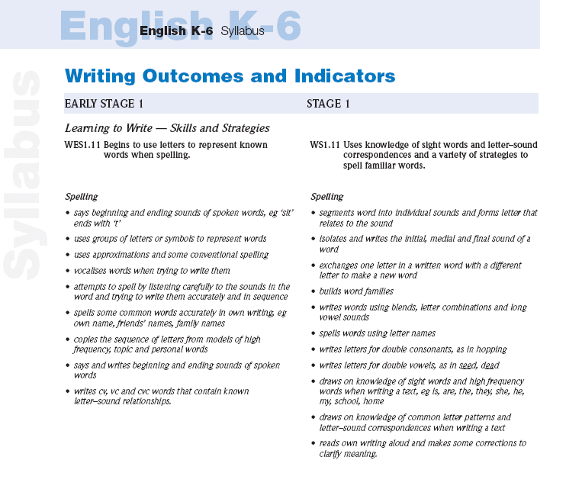

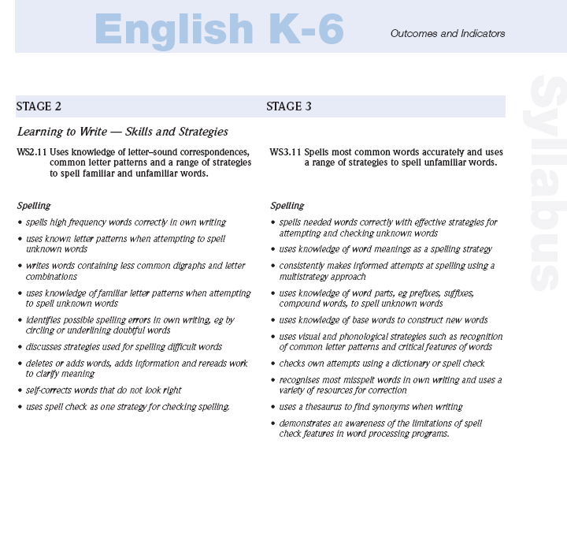

The Spelling Session Format
This is a suggested guide for Spelling Sessions
Session Components | Purpose and method
Modelled spelling  10 minutes | Consider students’ year level and stage expectations:  - Identify the ‘new learning’ of current lesson and why it is important.  - Make explicit the purpose of the new skill or strategy to be learned – a rule for word building, a memory tactic or proof-reading strategy.  - The new strategy should be modelled, thinking aloud to explain how to apply.  - Teacher demonstrates and discusses how effective spellers learn and apply spelling strategies. A previous related strategy may also be reviewed.  - Classroom spelling resources regularly referred to – word wall, list of rules, class or personal dictionary, colour chart, calendar, COGs topic bank, etc
Guided spelling  10-15 minutes | Teacher directs students to practise activities:  - Students are grouped on need using information from spelling assessments and students’ writing samples.  - Students guided (in pairs) to cooperatively complete tasks related to a specific ‘new’ spelling strategy – construct a word list with a shared letter pattern, learn a personal list of sight words and test each other on them, proof-read and correct errors in a piece of text.  - Students may also complete activities and play games to practise and consolidate skills recently introduced.  Teacher works with an ability based group:  - ‘Zoom in’ on a specific aspect that will be the focus of the lesson – telescoping, rehearsing a rule, discriminating between two letter patterns that represent the same sound, scanning a text systematically to identify spelling errors.  - Teacher guides students and observes them as they use a strategy, providing feedback as needed, until automaticity is reached.  - Students asked to demonstrate how to solve spelling problems while others in group watch and help if needed – apply a spelling rule to build words, use a strategy to spell new words or proofread a sentence and correct errors.  - Record which students may need additional activities to master skill.  - Review a previous skill or strategy – how to spell high-frequency or ‘demon’ words or use sources of information to attempt unknown words.  - Monitor how well students can recall and generalise strategies and program future guided session where needed.
Independent spelling  10-15 minutes | Teacher directs students to personal spelling contracts:  - Provide time for students to practise and gain control of own target words – these can be identified from their writing or may be teacher selected.  - Time may also be spent memorising and rehearsing class topic words.  - Teacher also provides learning activities to build vocabulary and use a range of authoritative sources – dictionary, thesaurus and spell-checker.  - Allow students to create texts for other students to proof-read.  - Encourage students to assist others to test their mastery of words.
Effectiveness of Spelling Learning Experiences –The following strategies may be incorporated into learning experiences. Whilst some may be considered ineffective for learning how to spell they may still
have relevance to the lesson eg. Developing vocabulary, listening activities etc

Highly Effective  - Making words and changing parts to make new words  - Building word families with like patterns  - Use of Elkonin boxes to represent the number of sounds in words  ch o p  - Talking about strategies to ‘problem solve’ spelling challenges  - Proofreading to locate and correct spelling errors  - Identifying base/root words in longer words with affixes  - Using strategies to remember how to spell words  - Identifying rules that govern sets of words  - Writing own glossary of technical words  - Writing clues to make a crossword  - Applying a rule to multiple words  - Targeting words misspelt in own writing | Moderately Effective  - Writing letters in silhouette boxes (especially for ES1 & St1)  - Writing a list of words in alphabetical order  - Inserting words in sentences  - Crosswords (vocabulary building)  - Reading sentences/passages containing list words (vocabulary building)  - Finding small words in longer words  - Identifying words that rhyme  - Changing verbs to past tense  - Finding dictionary meanings  - Matching onset and rime to make words  - Circling words with particular features  - Selecting correct homophone to complete sentence  - Selecting the correctly spelt version of a word | Ineffective  - Spelling non words, eg splog  - Unjumbling letters of words  - Writing words in sentences  - Finding antonyms of list words  - Unscrambling sentence words  - Word searches  - Boggle words  - Finding list words in text  - ‘Pick the odd word out’  - Matching words to pictures  - Adding endings when no rule is applied  - Completing jigsaw words  - Writing words 10 times under each other  - Using Look, Say, Cover, Write, Check for words other than sight words

SPELLING RULES
STAGE 1
Year 1 – Exposed to Year 2 – Consolidate Can be taught in ANY order
Rule | Example | Registration
- Most words form a plural by adding –s  - Words ending in –ay, –ey and –oy, just add the ending  - Words containing a short vowel followed by a single consonant must double the consonant before adding –ed or –ing  - Words with a short vowel followed by one consonant must double the consonant before adding –er [link to above rule]  - When a word ends in –e, drop the –e, before adding -ing or -ed  - Some verbs do not take a past tense –ed ending, but change their form  - Double l, f or s after a single vowel at the end of a word  - When c goes in front of a, o or u, it sounds like k  - When c is followed by e, i or y, it sounds like s [link to above]  - k goes in front of e and i [link to above]  - ck is only used after a short vowel sound  - When g is followed by e, i or y, it sounds like j  - q is always followed by a u  - When a word ends in l, double the l, before adding –ed, –ing or –er | dog – dogs cat – cats  bay – bays toy – toys  stay stayed staying stays  bat – batted – batting  shop – shopper – shopping  run – runner  win – winner  big – bigger  love – loving – loved  dare – daring – dared  is/was has/have ran/run go/went write/wrote  call tall stuff  mass less  cat cot cut  cent circus cycle  keg kick  sack neck brick lock duck packet tickle  gentle rage giant gypsy  gesture  queen, quit, aqua  [except in QANTAS]  travel – travelled – travelling – traveller

SPELLING RULES

STAGE 2
Review and Consolidate ALL Stage 1 Rules
Year 3 – Exposed Year 4 – Consolidate Can be taught in ANY order
Rule | Example | Registration
- Words that end in sh, ch, s, ss, x and z form plurals by adding –es  - When a word ends in a consonant followed by a y, change the y to i before adding –es  - Some words that end in f, form the plural by changing the f to v then adding –es  - Some words change their form when they become plural  - When adding –ing to words that end in y, leave the y  - For words that end in a consonant and y, change the y to i before adding –er or –est  - If a word ends in y, change it to i before adding –ly  - Final –e is left out when adding –y  - Omit the final –e from a root word, before adding an ending that begins with a vowel  - Keep the final e if the ending starts with a consonant  - Just add endings to one syllable words with two vowels  - When w is followed by a, the a is usually pronounced like short –o  - When w is followed by ar, the ar is pronounced like –or  - When w is followed by or, the or is pronounced like –er  - –e on the end of a word generally makes the vowel say its name  - i before e except after c [except: neither, foreigner, sovereign, seize, counterfeit, leisure, forfeit, weird]  - e before i is pronounced -ay  - The sound ee on the end of a word is nearly always represented by –y | dishes churches gases classes boxes buzzes  cry cries fly flies  spy spies  leaf leaves  half halves  mouse/mice goose/geese  spy spying  enjoy enjoying  easy easier easiest  day daily steady steadily  scare scary bone bony  have having  crave craving  care careful  confine confinement  seat seating seated  spoil spoiling spoilt  was wash wad want wand wander wasp wattle waffle  war warn warble ward  warden warm warp wart  word worm worth worse worst world  late make theme scene bike bone cube  believe chief niece receive  weigh veil vein reign  neighbour freight  key happy silly party monkey [except coffee and committee]

SPELLING RULES
STAGE 3
Review and consolidate ALL Stage 1 and Stage 2 Rules
Year 5 – Exposed Year 6 – Consolidate Can be taught in ANY order
Rule | Example | Registration
- If a word ends in ie, change the ie to y before adding –ing  - When –full and –till are used as a suffix, drop one l  - If a word ends in a consonant followed by a y, change the y to i before adding a suffix  - To add –able or -ous to a word, drop the e [exceptions: manageable, noticeable, courageous]  - all or well at the beginning of a word, drop one l  - When a word ends in –ic, add –al before adding –ly  - Words of more than one syllable, and the final syllable is stressed, double the final consonant before adding a suffix  - Don’t double the final consonant when the last syllable contains two vowels or is not stressed  - When a word ends in –our change to  -or before adding a suffix  - Verbs ending in -c, add -k before adding a suffix beginning with a vowel  - Most words ending in –o add –es to form the plural  - Words ending in a double vowel with an –o sound, just add -s | lie lying die dying  care + full = careful  un + till = until  beauty + full = beautiful  lovely lovelier  bury buried  note notable  desire desirable  fame famous  all + most = almost  well + come = welcome  magic magically  forgot forgotten  occur occurring  appear appeared  whisper whispered  encounter encountering  humour humorous  humorist  traffic trafficking  picnic picnicking  panic panicked  tomato tomatoes  radio radios  video videos

Sight words – Kindergarten
the | of | and | to | a
in | that | is | was | am
he | for | it | with | as
his | on | be | at | run
by | I | this | had | not
are | but | or | can | no
down | up | an | they | look
you | girl | boy | we | if
all | mum | dad | did | my
see | stop | go | her | little
big | red | play | him | been
has | will | from | have | she
like | me | cat | dog | school
love | jump | walk | skip | my
baby | brother | sister | shop | good
went | got | friend | here | comes
where | over | there | some | out
their | house | said | not | yes
says | made | birthday | party | get
here | book | saw | when | children

Core List – Year 1
a | all | am | an | and
are | as | at | away | baby
be | big | book | boy | but
by | can | car | cat | come
dad | day | did | do | dog
doll | down | father | for | from
get | girl | go | good | got
had | has | have | he | her
here | him | his | home | I
if | in | into | is | it
jump | just | like | little | look
man | me | mother | mum | my
no | not | of | off | on
one | over | play | put | ran
run | said | saw | school | see
she | so | some | that | the
them | then | they | this | to
took | under | up | us | walk
was | way | we | well | went
when | will | with | yes | you
Also…
* Numbers 1 to 10

Core List – Year 2
about | after | afternoon | along | also
again | any | anyone | anything | another
around | ask | because | before | best
been | better | brother | called | came
children | coming | could | cry | dear
does | doing | door | don’t | didn’t
eat | every | face | fast | find
first | found | friend | gave | give
going | gone | half | happy | head
hear | house | i’m | inside | kind
letter | live | lunch | long | made
make | many | Miss | morning | Mr
Mrs | myself | name | never | new
next | nice | night | now | old
once | open | our | out | people
place | pretty | read | road | should
sister | something | start | story | their
there | these | thing | think | time
told | today | too | two | very
want | water | were | what | who
would | year | yesterday | your | Ms
Also…
* Shapes * Seasons
* Days of the week * Colours
* Months of the year * Numbers to 20, 30, 40, 50, 60 etc.
* Personal street, suburb names

Core List – Year 3
weeks | strange | floor | packed | leave
beautiful | that’s | person | ring | station
someone | won | people | side | stay
felt | air | straight | watch | try
street | brought | town | city | early
along | finally | across | sudden | voice
high | i’ll | asleep | talk | should
hello | than | box | against | large
television | watchg | clothes | australia | course
died | animal | colour | cold | let’s
everybody | anything | different | corner | slept
light | bird | dollars | nothing | sure
quickly | book | feet | parents | wouldn’t
show | even | own | seen | write
slowly | hair | used | sent | able
space | games | goes | talk | already
everything | hard | rain | train | during

Core List – Year 4
one | first | July | suddenly | minute
two | second | August | only | island
three | third | September | through | love
four | fourth | October | why | birthday
five | fifth | November | while | reached
six | sixth | December | small | tried
seven | seventh | Summer | here | Couldn’t
eight | eighth | Autumn | few | under
nine | ninth | Winter | money | behind
ten | tenth | Spring | always | kept
eleven | Monday | past | family | both
twelve | Tuesday | planet | great | must
thirteeen | Wednesday | please | it’s | ready
fourteen | Thursday | where | right | wasn’t
fifteen | Friday | which | finish | week
sixteen | Saturday | more | hour | say
seventeen | Sunday | until | knew | each
eighteen | January | other | o’clock | happen
nineteen | February | white | most | sometimes
twenty | March | know | caught | being
gone | April | hope | whole | everywhere
sea | May | might | captain | ago
funny | June | war | uncle | but

Core List – Year 5
eleventh | quite | though | information | accept
twelfth | favourite | worrying | usual | either
amazement | intend | they’re | tomorrow | enormous
believe | increase | unfortunately | furniture | excellent
broken | imagine | value | fantastic | fault
choice | limit | valuable | mountain | discuss
cautious | listened | various | distance | height
collect | lonely | who’s | science | herd
complete | meant | you’ve | discovered | judge
difference | nearly | thought | cupboard | language
easiest | neither | decided | telephone | measurement
easily | necessary | really | dessert | nation
except | noticeable | presents | however | opportunity
entire | pause | arrived | happiness | preparation
experience | position | followed | accommodation | popular
famous | possible | brought | deliver | regular
friendship | previous | holiday | enemy | serious
farther | properly | wrong | entrance | situation
frightened | separate | lounge | interest | rhythm
goodbye | tongue | treasure | succeed | section
strength | stationary | umbrella | recommend | recent
successful | truly | universe | responsible | recognise
stationary | temperature | struggle | service | permanent

alright | hurrying | sufficient | terrible | disappoint
aeroplane | happiest | suggest | instead | either
amazement | intend | they’re | tomorrow | enormous
believe | increase | unfortunately | furniture | excellent
broken | imagine | value | fantastic | fault
choice | limit | valuable | mountain | discuss
cautious | listened | various | distance | height
collect | lonely | who’s | science | herd
complete | meant | you’ve | discovered | judge
difference | nearly | thought | cupboard | language
easiest | neither | decided | telephone | measurement
easily | necessary | really | dessert | nation
except | noticeable | presents | however | opportunity
entire | pause | arrived | happiness | preparation
experience | position | followed | accommodation | popular
famous | possible | brought | deliver | regular
friendship | previous | holiday | enemy | serious
farther | properly | wrong | entrance | situation
frightened | separate | lounge | interest | rhythm
goodbye | tongue | treasure | succeed | section
strength | stationary | umbrella | recommend | recent
successful | truly | universe | responsible | recognise
stationary | temperature | struggle | service | permanent

Core List – Year 6

NAPLAN Difficult Words

abandoned
absolutely
access
acknowledge
actually
adjusted
advantage
affect
agencies
agreeable
alien
allergic
amuse
annual
answer
area
assess
attachment
attempt
attention
attractive
auction
author
autograph
awesome
barely
beautiful
behaviours
benefit
beware
bough
boulder
boundary
brake/break
breathless
brethren
brief
burglar
business
calm
carriage
category
celebration
certain
character
cheques
chocolate
circuit
college
community
competition
complaining
complete
concerned
confidence
consider
considerate
continued
contraptions
convince
coordinator
corpses
creature
crevice
criminal
crystal
curious
damage
dangerous
decided
decision
decorate
defence
delicious
demolished
demonstrate
depot
depression
deprived
deserts
dessert
designed
detective
digest
disappear
disappointed
discover
drawer
drought
dye
easiest
edible
educational
eerie
effect
effective
emerged
endangered
energy
engage
engine
enjoyable
enormous
ensure
episode
especially
esteem
except
exciting
exert
expensive
experience
explosion
extremely
famous
favourite
features
February
fellowship
fete
fibre
fiction
field
fierce
formal
formation
fractures
fragile
frenzied
frightened
furniture
further
galaxy
generation
gesture
gigantic
glacier
global
gnawed
goblet
government
graphics
grumble
guess
hammock
haphazard
haste
haul
healthy
heir
herd
hesitated
hilarious
history
hoarse
honest
horrified
hostel
humorous
hurriedly
hygiene
illegal
imagination
imaginative
implicate
improvement
including
inexpert
information
informative
insane
insolent
insurance
intelligent
intention
interest/ing
interrupt
invisible
irrational
issue
jeopardy
jettison
journey

kidnapped
kiosk
knowledge
language
league
library
lightning
litany
literacy
lullaby
lunar
lyrebird
majestic
malt
martial
matted
mayor
measured
medicine
medieval
minerals
molecule
molten
moult
mucus
muscle
muscular
museum
mysterious
mystery
mystic
myth
natural
negligent
neighbour
niece
normality
nutrition
notice
oblige
observe
obviously
occur
ogre
omit
opportunity
opposition
optical
optimist
option
organise
origami
oxygen
parallel
pedestal
personalities
pincer
plait
pleasure
prankster
pray
precious
predators
presence
prey
principal
principle
professor
pumpkin
punctual
pure
pursuit
quaint
quay
quench
query
queue
radial
ravine
razor
realistic
receive
recent
recognise
recommend
rectangular
relationships
relevant
reliving
reluctant
remnant
remorse
replenish
require
resources
responsible
rhyme
ridiculous
rogue
saxophone
scavenger
scene
sceptical
schnitzel
scientific
seize
sewage
sewerage
shoulder
shrieked
signal
skeleton
slaughter
society
sought
spectacular
stammered
stomach
submarine
subsided
success
suitable
summoned
supervision
surrounded
survive
system
taffeta
talons
tarantula
taught
technique
temperature
tension
tentacles
terrace
terrible
terribly
territory
thermonuclear
travelled
treasure
uncomfortable
unexpectedly
unfortunately
unique
unnatural
upholsterer
urban
urgency
useless
valuable
vegetation
verdant
vessel
victory
villages
violence
vision
voyage
vultures
wary
weary
wearisome
weighed
weight
weird
wholly
witchery
women
wonderful
wrapped
wrinkle
written
yacht
yearn
yield
youngster
youthful
zany
zenith
zodiac
zoology

NAPLAN Challenge Words

accelerating
accidentally
accommodation
accumulate
acquainted
acquire
adrenaline
aisle
annihilate
annoyance
appearance
appreciated
appropriate
archaeology
awkwardly
baulk
beige
belligerence
benefited
benevolent
blasé
brevity
brilliance
brusque
buoy
camouflage
carcasses
changeable
climatic
colloquial
colossal
column
competence
complementary
complimentary
conscience
conscious
consequently
correspond
courageous
cylinder
debris
decomposed
deficient
definitely
delicious
dependency
desiccate
desperate
desperation
dominant
draught
dungeon
effervescent
efficient
embarrassed
environment
esteem
euphoric
exaggerate
exhilarating
explanatory
facilities
fascinating
fluorescent
fuchsia
furnace
futile
gauge
ghoul
grandeur
guaranteed
guillotine

haemoglobin
hallucinate
helium
hesitance
humanitarian
imaginable
incandescent
incompetent
inconsequential
inconsolable
incorporate
indecipherable
insanity
interrogate
intrigue
intriguing
iridescent
irrelevant
irresponsible
judicial
kaleidoscope
kayaking
lacerate
leisure
lieutenant
liquefy
litigious
longevity
luminescent
magnificent
malaria
mandible
manoeuvre
mathematician
mediaeval
miniature
minions
mischievous
misconstrue
misogyny
naivety
narcissist
necessary
nonchalant
noticeable
notoriety
nuisance
obedience
obnoxious
obscure
observation
obsessed
obsessive
occasionally
occasions
occurrence
opaque
oscillate
peculiar
personally
persuade
persuasive
pessimistic
phosphorescent
physically
plateau
population
precise
prevalence
privileged
proposition
psychiatrist
psychic
psychology
purest
purist
quiescent
racquet
rancour
realistically
recognisable
redemption
reign
rein
reminiscent
responsibility
resurrect
resuscitate
rhythm
ricochet
rigorous
sabotage
scimitar
scintillate
separate
silhouette
skulduggery
sovereign
stationary
stationery
sufficient
telekinesis
temperamental
temporary
therapeutic
thoroughly
tournament
tsunami
ubiquitous
unconscious
unnecessary
vertebrates
vicious
voila
vulnerable
waive
wilful
wondrous
wraith
wrought
zephyr

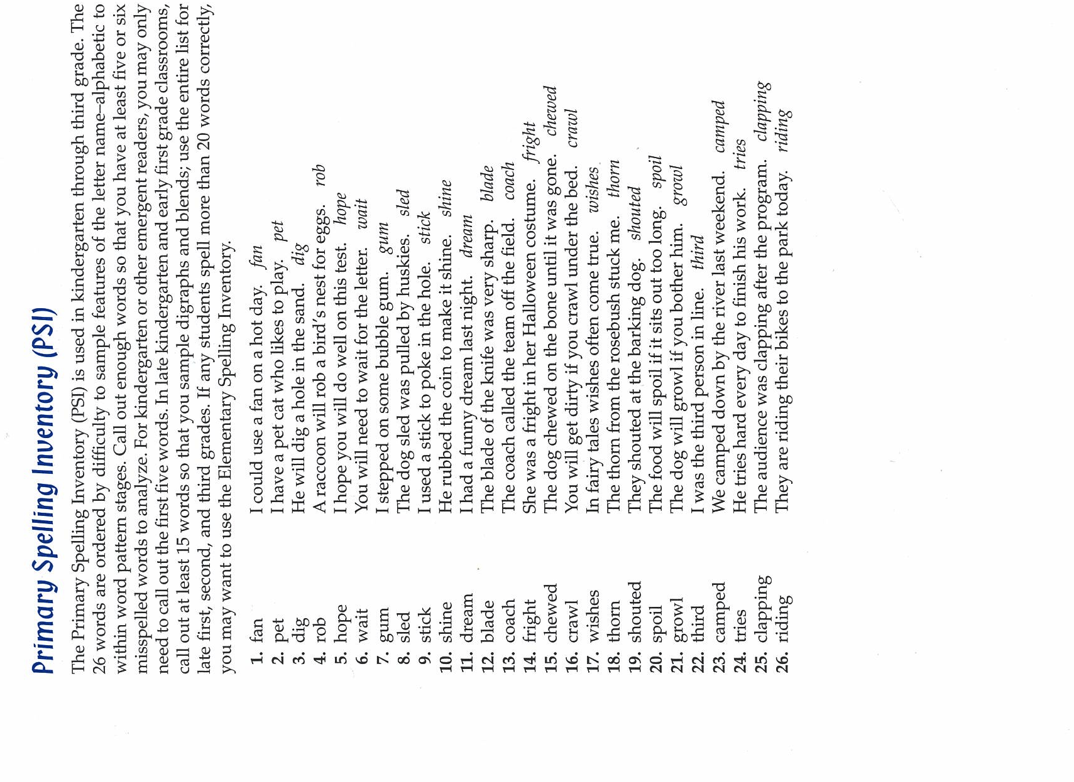

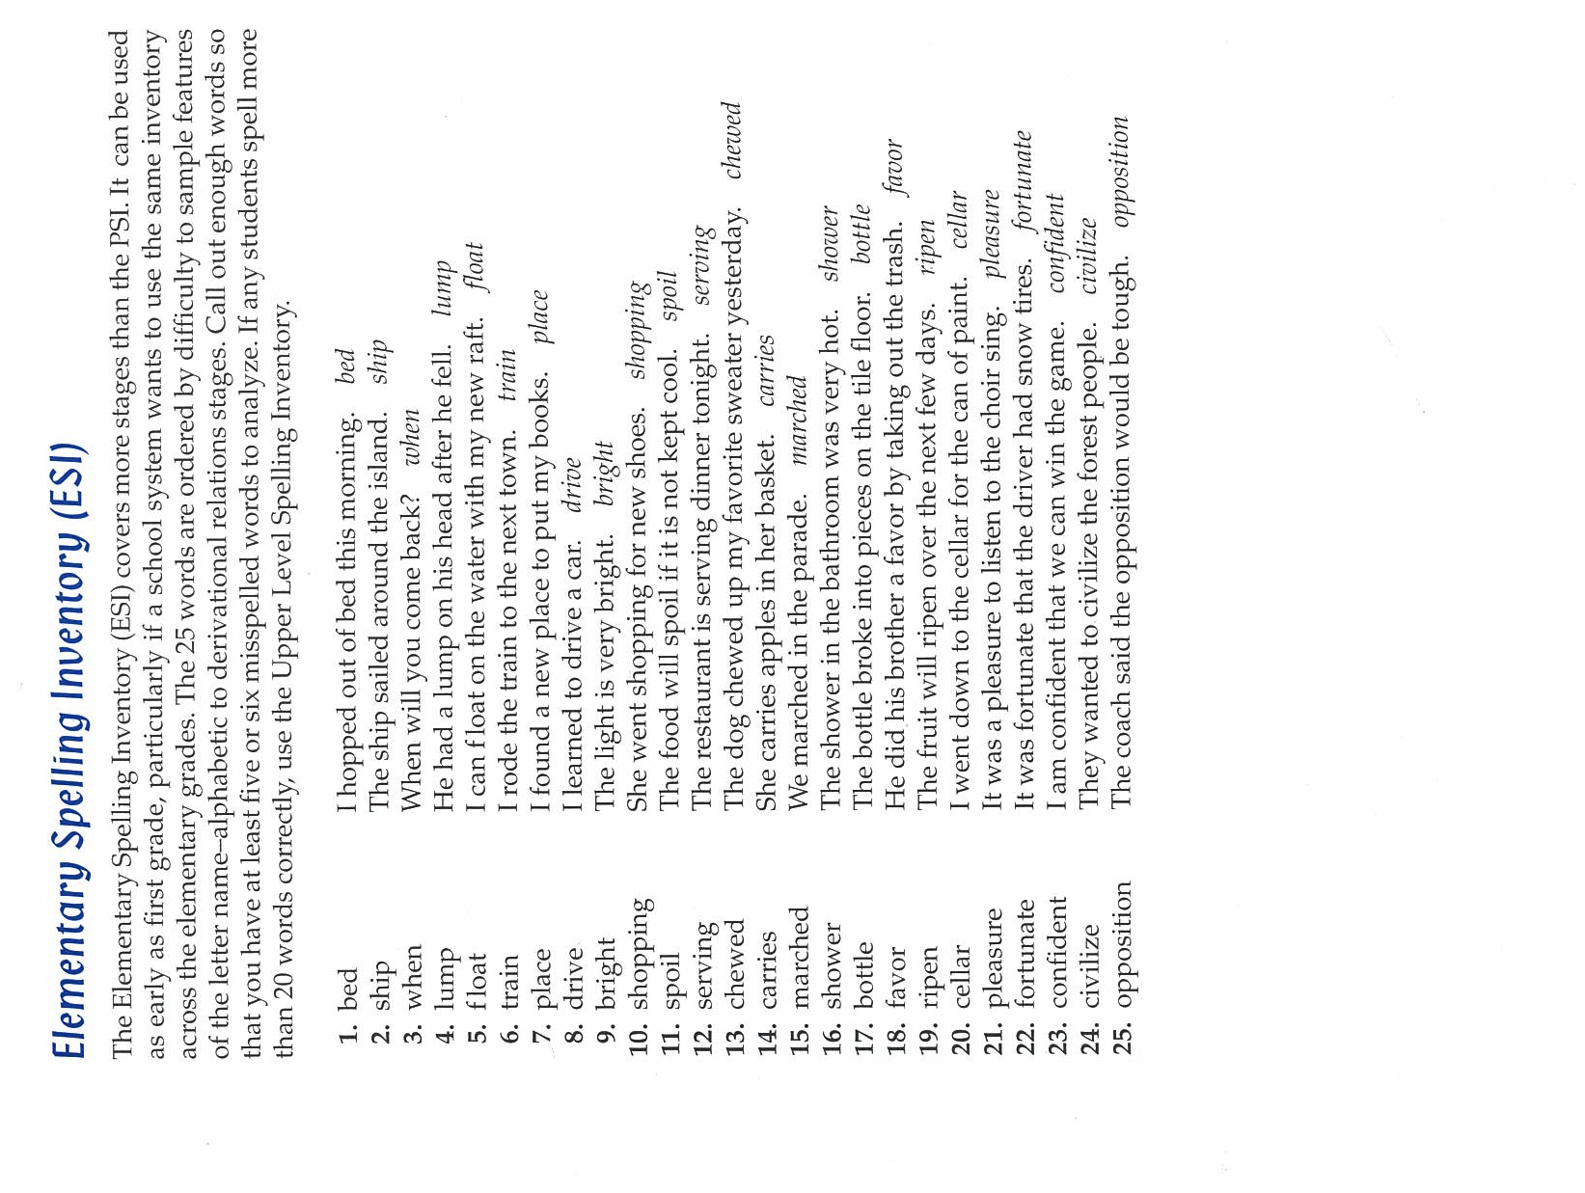

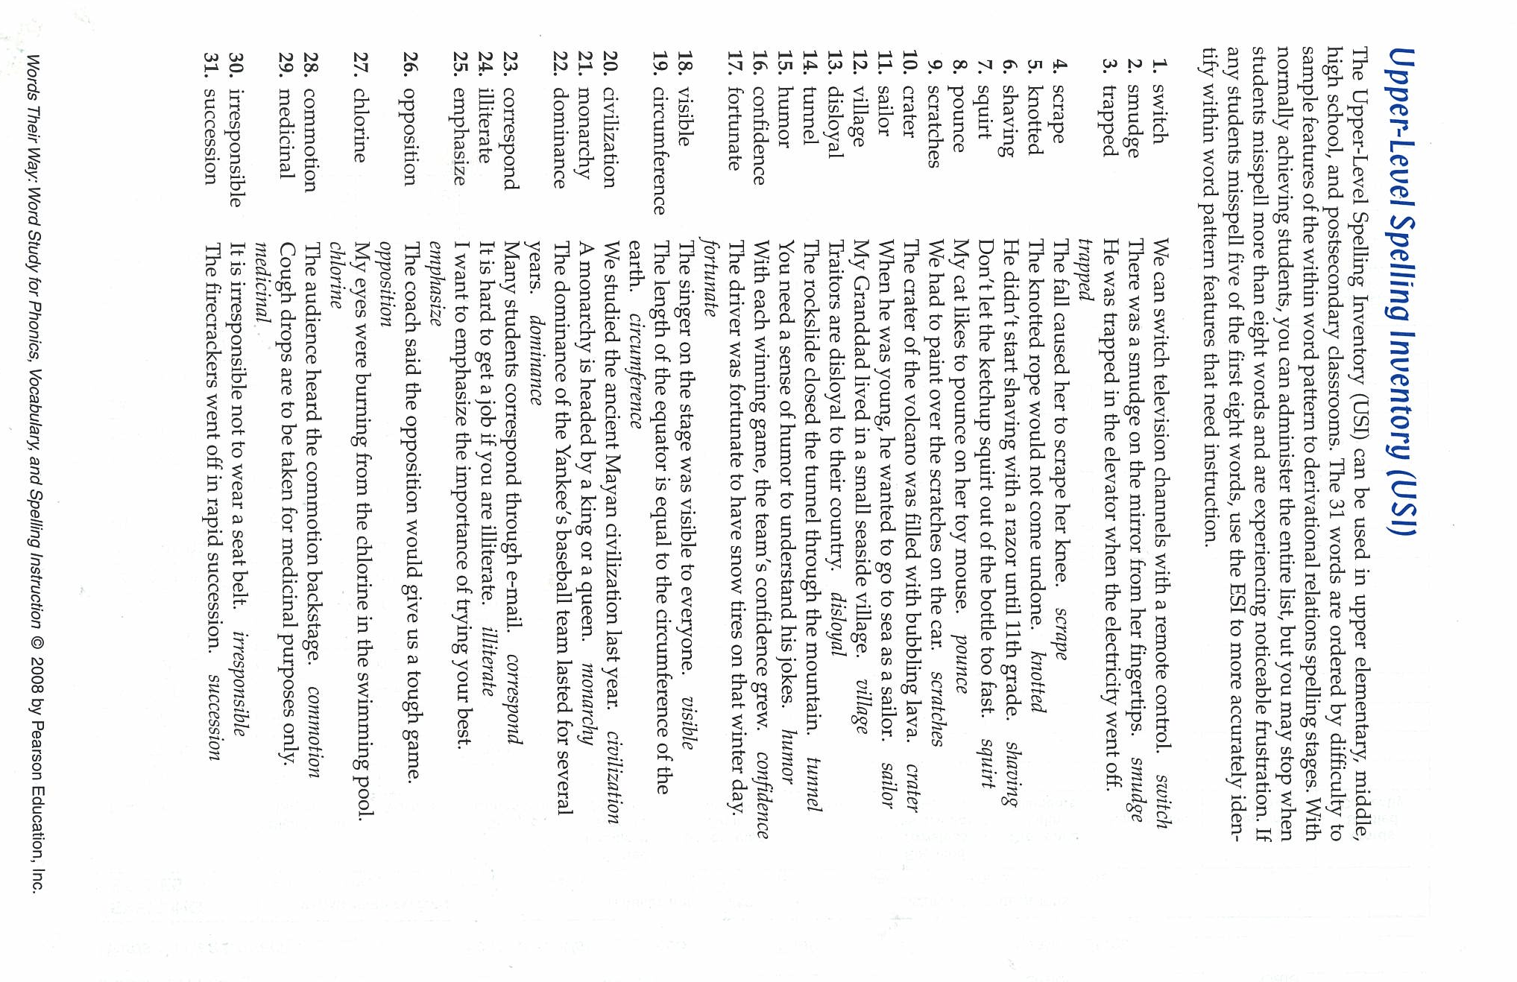

Spelling Inventory
 | Primary | Elementary | Upper level
1
2
3
4
5
6
7
8
9
10
11
12
13
14
15
16
17
18
19
20
21
22
23
24
25
26
27
28
29
30
31
Name ___________________________________________ Date ______________________

Glossary

Acronym: A word formed from the initial letters in a phrase
Alphabetic principle: An assumption underlying alphabetic writing systems that speech sounds are represented by letters.
Analogy: In spelling, using a known word to help in the spelling of other words.
Base Word: A word to which prefixes and suffixes may be added to create words relate in meaning
Blend: The joining of sounds represented by two or three letters with minimal change in those sounds – for example, spl, in split.
Blended Word: A word formed from portions of two words – e.g.. smog = smoke + Fog. The meaning of a blended word is also a combination of the meaning of the two words it came from.
Comparative Form: Form of an adjective or adverb to compare two items
Compound Word:
1) A word having its meaning the meaning of the two or more smaller words within it – e.g., the compound word roommates relates to the meaning of room and mate
2) A word consisting of two or more free morphemes (the smallest units of Meaning) with a meaning that is unrelated to the meanings of the morphemes e.g., butterfly.
Consonant:
1) A speech sound made by partial or complete blockage of the breath
2) A letter of the alphabet representing any of these sounds.
Contraction: The shortening of a spoken or written expression by the omission of one or more sounds or letters. There are two types of contractions: one is formed from two words in which the omitted letters are represented by an apostrophe (we’re); the other is the shortened form of one word in which the omitted letters are not represented by an apostrophe (Dr).
Derivative: An English word or portion of a word derived from other languages such as Greek, Latin, or Old French.
Digraph: Two or more letters that represent one speech sound – e.g., the vowel digraphs eigh and ai and the consonant diagraphs th and ch.
Diphthong: A vowel sound created by combining two vowel sounds, such as in buy.
Eponym: A word derived from the name of a person, a place, pr an institution,
E.g.; pasteurization, after Louis Pasteur.
Generalization: In spelling, a general conclusion about how written English works.
High-Frequency Words: Words used often in reading and writing
Homographs: Words that sound different, but are spelt the same and have different meanings E.g.; minute (time) and minu/te table (small)
Homonyms: Words that sound the same and are spelt the same, but have different meanings E.g.; table (furniture) and table (math)
Homophones: Words that sound the same, but are spelt differently and have different meanings E.g.; hear and here.
Interactive writing: A writing partnership in which the teacher and the students plan and compose texts together, and the teacher shares the pen with the students. It provides opportunities for the teacher to demonstrate and the children to practice strategies good writers and spellers use.
Letter name: A consistent label given to each letter of the alphabet.
Meaning strategy: Using the structural relationships between words when attempting to spell unknown words, E.g.; using the generalization that past tense if often indicated by the suffix Ed when attempting to spell an unknown word in the past tense.
Modeled writing: Demonstrating writing in front of students or introducing previously written print.
Onset: The consonant or consonants preceding the vowel in a syllable, E.g.; ple, /l/ in look.
Phoneme: The smallest sound unit of spoken language. E.g.; the word telephone has seven Phonemes: /t/-/e/-/l/-/e/-/f/-/o/-/n/.
Phonemic Awareness: Awareness of the separate sounds in words.
Phonic Strategy: Using the sound-letter relationships in words when attempting to spell.
Unknown words, E.g.; using the generalization that the /w/ sound is usually represented by the letter w when attempting to spell an unknown word with /w/ sound.
Phonics: Letter-sound correspondences in a language.
Phonological Awareness: The ability to hear and manipulate sound units in the language, such as syllables, onsets and rimes, and individual sounds in words (phonemes).
Phonology: The study of speech sounds and their functions in language.
Prefix: An affix attached before a base word that changes the meaning of the base word.
Rime: The first vowel and any following consonants or vowels of a syllable
E.g.; /ook/ in look.
Schwa: In English, the midcentral vowel in an unstressed syllable. E.g.; /a/ in above, and /u/ in industry.

Shared Writing: A writing partnership in which the students and the teacher together compose a piece of writing, then the teacher writes the piece. Unlike interactive writing, the pen is not shared between the students and the teacher, even though the students may suggest how the words should be spelt.
Spelling Patterns: A group of letters representing a sound, including groups of letters, such as ould and ear, and diagraphs.
Stress: The emphasis or degree of loudness placed on a syllable.
Suffix: An affix attached to the end of a base word that changes the meaning or grammatical function of the word.
Superlative Form: Form of an adjective or adverb used to compose more than two items.
Syllable: The smallest unit of sequential speech sounds consisting of either a vowel sound or a vowel sound with one or more consonant sounds.
Visual Strategy: Using the visual relationships between words when attempting to spell unfamiliar words, E.g.; knowing that the spelling pattern eigh represents the /ay/ sound in eight when attempting to spell the word weigh.
Vowel:
1) A voiced speech sound made without stoppage or friction of the air flow as it passes through the vocal tract.
2) A letter of the alphabet representing any of these sounds: The letters A, E, I, O, U,
Word Family: A group of words related in meaning. Words in a word family might be derived from the same base word and have different prefixes and/or suffixes added to it. E.g.; the word replays is derived from the base word play; the prefix re and the suffix s have been added to form a new word related in meaning to the base word, play. Compound words may also be part of a word family. E.g.; the words playground and playpen are related in meaning to the word play. Other word families may be based on derivatives. E.g.; the words photographer and telephoto are related in meaning to derivative photo.

