

**Practices that accelerate learning**

* **Mindset**

**Fixed Mindset**

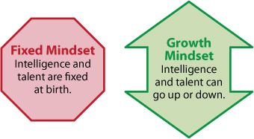‘I won’t try new and difficult things.’

‘If I don’t try hard then I won’t make a mistake.’

‘I just give up easily.’

‘It doesn’t help if I try hard.’

‘I feel jealous when other kids do well.’

**Growth Mindset:**

‘I like to try new things.’

‘I keep trying until I can.’

‘The effort that I put into my work helps me learn.’

‘I can learn from mistakes.’

‘When other kids do well, I am inspired.’

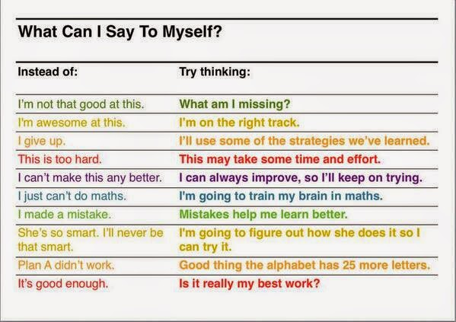

Growth Mindset video:

* <https://www.youtube.com/watch?v=ElVUqv0v1EE>

Video on the brain and growth mindset:

* <https://www.youtube.com/watch?v=XSzsI5aGcK4&list=PLwrHA9rJu3ybuh85eQ6CTLlC67iQpbY8_>
* **The Learning Pit**

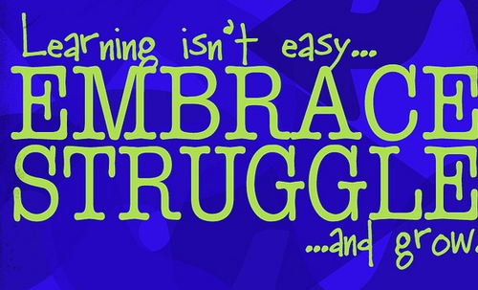

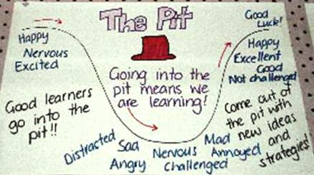

Neuroplasticity

* <https://www.youtube.com/watch?v=ELpfYCZa87g&list=PLwrHA9rJu3ybuh85eQ6CTLlC67iQpbY8_&index=2>

Taking on challenges:

* <https://www.youtube.com/watch?v=g7FdMi03CzI>