

**Habits worth developing**

It is important to teach both the content of the curriculum and to provide students with multiple opportunities to develop a repertoire

of effective habits that they can call upon at any time in their life when learning something new.

These learning habits will be explicitly taught in every classroom.

The learning habits fall under five dispositions**:**

* **The EMOTIONAL aspects – Self Regulation**
* **The ETHICAL aspects – Responsibility**
* **The SOCIAL aspects – Reciprocity**
* **The COGNITIVE aspects – Resourcefulness**
* **The STRATEGIC aspects – Reflectiveness**

We can think of the dispositions as being like groups of ‘*learning muscles’,* which can be exercised to develop their strength and stamina.

Why skills are not enough

The 20 elements on the HOW2Learn chart are called habits because we want students and teachers to understand them so well that they become something that, in time, is an unconscious or natural part of their learning.

Now meet the How2Learn Super heroes which have been created to strengthen understanding of the attributes that highly effective learners display when facing the challenges of learning :

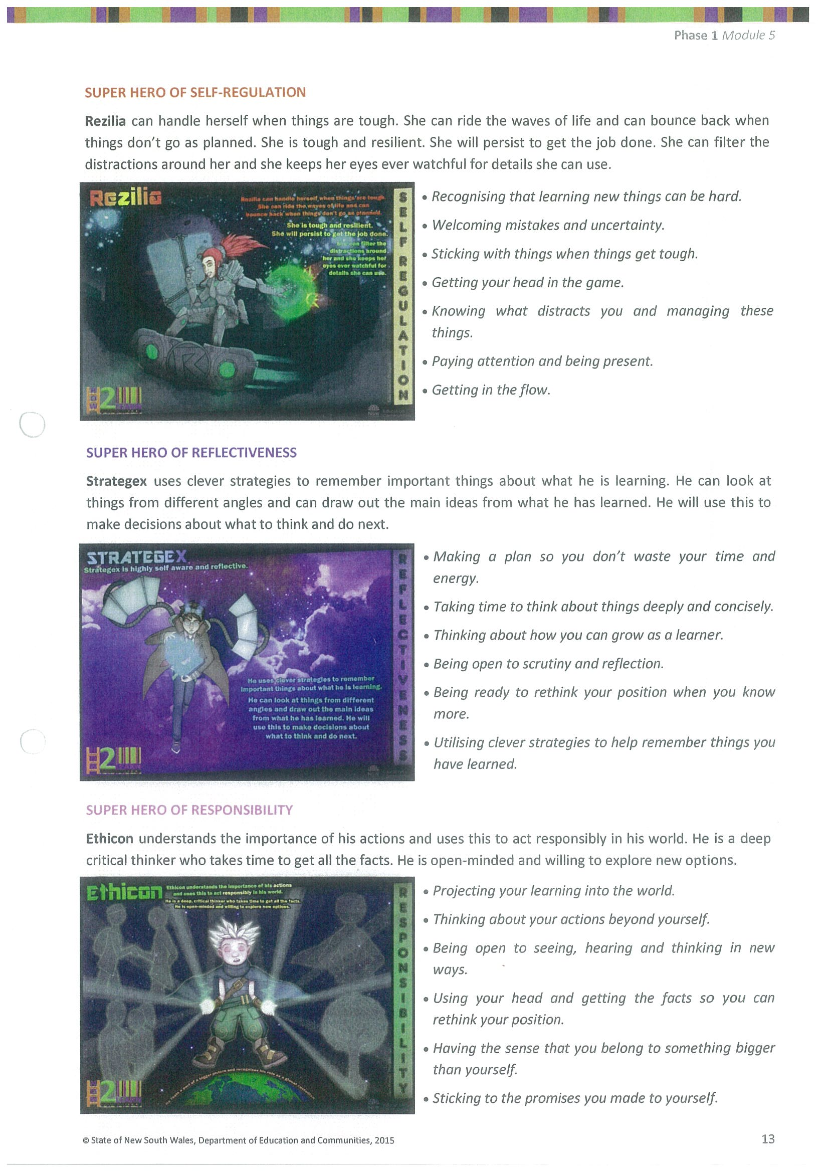







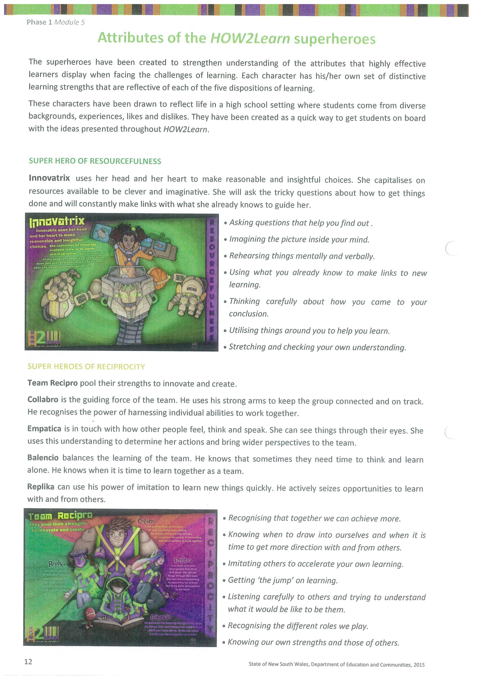











These 20 learning habits will be explicitly taught to students over the next 5 terms, starting in Term 4, 2015 and finishing in Term 4, 2016. They will be implemented and embedded in classroom practices and programs by students and teachers.